**IOT BASED SMART PARKING SYSTEM**

**INTRODUCTION:**

An Internet of Things (IoT) based smart parking system is a revolutionary solution that leverages the power of connected devices and sensors to efficiently manage and optimize parking spaces. Traditional parking systems often lead to congestion, wasted time, and increased pollution due to the endless search for available parking spots. In contrast, IoT-based smart parking systems use a network of sensors, cameras, and data analytics to provide real-time information about parking space availability, streamline the parking process, reduce traffic, and enhance the overall urban mobility experience. This technology not only benefits drivers but also contributes to more sustainable and smarter cities by making the best use of limited parking resources.

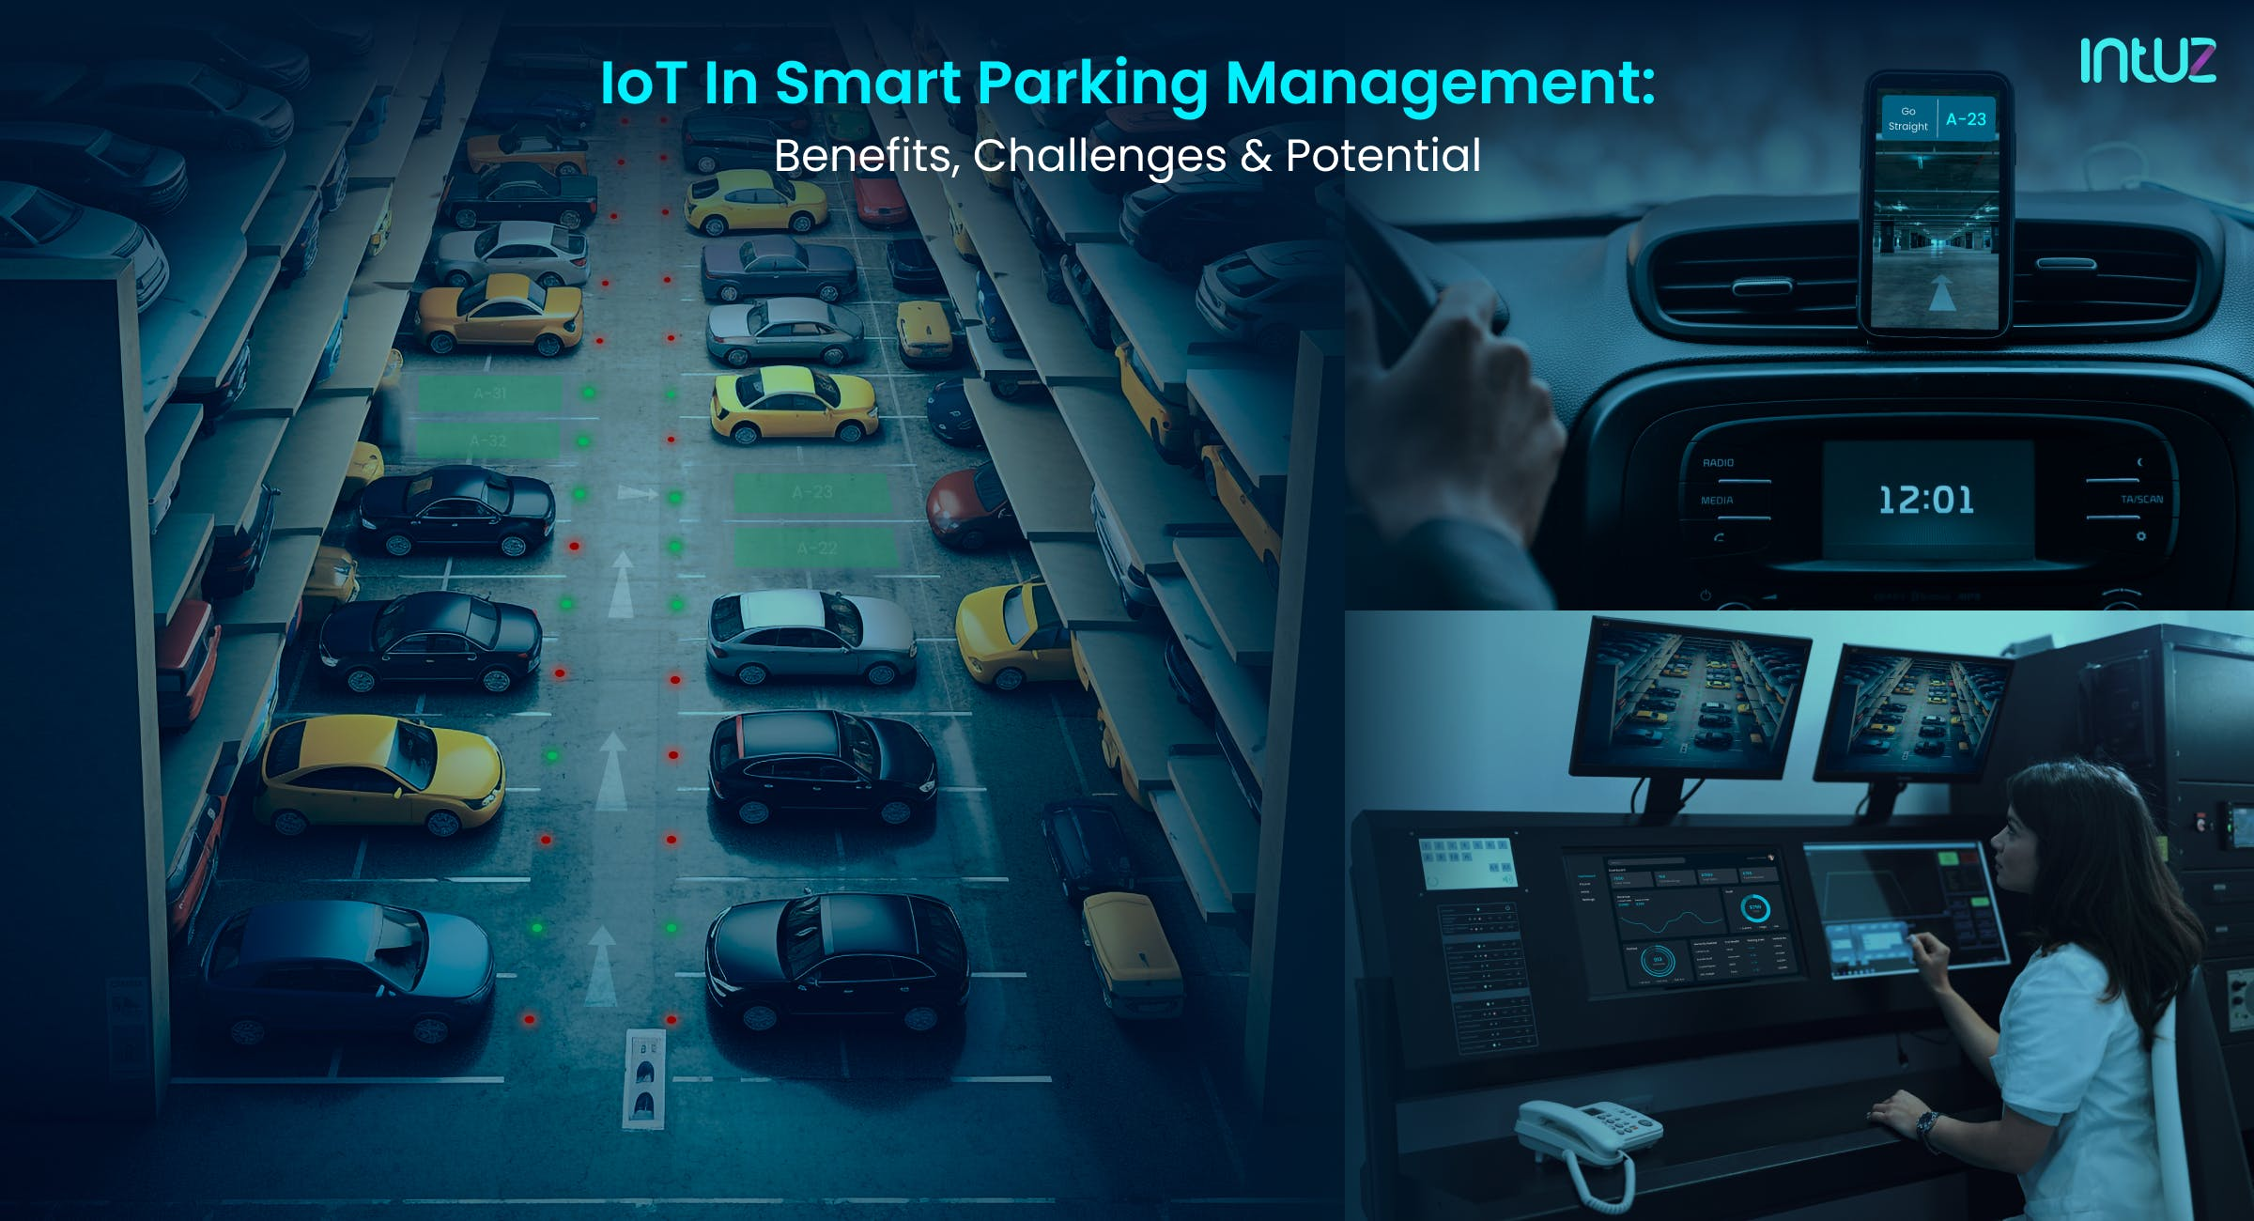

**INNOVATIVE REQUIREMENTS:**

A smart parking lot system can incorporate several solutions to improve efficiency and user experience. Here are some key components:

* **Sensors and Cameras:** Utilize various types of sensors (e.g., ultrasonic, infrared) and cameras to monitor parking spaces and gather real-time data on occupancy.
* **IoT Connectivity:** Enable communication between sensors and a central management system through the Internet of Things (IoT) for seamless data collection and analysis.
* **Data Processing and Analysis:** Employ software to process the data collected by sensors and cameras to determine parking space availability and occupancy status.
* **Mobile App Integration:** Develop a user-friendly mobile app that allows drivers to check real-time parking availability, reserve spots, and navigate to the nearest available space.
* **Payment and Ticketing System:** Integrate a payment gateway for automated parking fee collection, which can be linked to the app for a seamless experience.
* **Automated Entry/Exit Gates:** Install automatic barriers or gates that can be controlled through the app once a parking space is reserved and paid for.
* **Guidance and Navigation System:** Implement a system that guides drivers to available parking spaces through visual or audio cues within the app.
* **License Plate Recognition (LPR):** Use LPR technology to automate entry and exit for registered vehicles, eliminating the need for physical tickets.
* **Real-time Updates and Notifications**: Send notifications to users about their parking reservation status, reminders for expiration, and directions to their reserved spot.
* **Smart Payment Options**: Provide various payment options, including mobile wallet integration, credit/debit card payments, and contactless methods for convenience.
* **Integration with Public Transportation**: If applicable, integrate with public transportation systems to offer a seamless transition from parking to transit.
* **Security and Surveillance**: Implement robust security measures including CCTV cameras, alarms, and security personnel to ensure the safety of vehicles and users.
* **Energy Efficiency Measures**: Incorporate energy-saving technologies such as LED lighting, solar panels, and efficient HVAC systems to reduce environmental impact.
* **Analytics and Reporting**: Utilize data analytics to generate reports on parking space utilization, revenue, and user behavior for continuous system optimization.
* **Scalability and Flexibility**: Design the system to be easily scalable to accommodate additional parking spaces or locations, if needed.

**CIRCUIT DIAGRAM:**

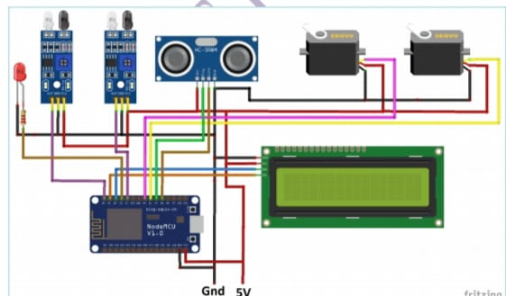

**DEVICES SETUP:**

* **Hardware Components:**

- IoT Devices: Choose suitable IoT sensors (e.g., ultrasonic, magnetic, or infrared) to detect vehicle presence in parking spots.

- Microcontrollers: Use microcontrollers like Arduino, Raspberry Pi, or specialized IoT platforms (e.g., ESP8266/ESP32) to interface with the sensors.

- Connectivity: Ensure the devices have network connectivity, either via Wi-Fi, cellular, or LoRa.

* **Sensor Placement:**

- Install sensors in parking spots, ideally one per spot, to detect vehicle occupancy.

* **Data Collection:**

- Program the microcontrollers to collect data from the sensors, such as occupancy status (occupied or vacant) and potentially additional data like duration of occupancy.

* **Data Transmission:**

- Transmit the collected data to a central server or cloud platform for processing and storage.

* **Server or Cloud Setup:**

- Set up a server or cloud platform to receive and process data from the IoT devices. You can use platforms like AWS, Azure, or Google Cloud for this purpose.

* **Data Processing:**

- Implement algorithms to process the data, monitor parking spot status changes, and manage the information effectively.

* **User Interface:**

- Create a user-friendly interface for users to check parking spot availability. This can be a mobile app, a web application, or even physical displays near the parking area.

* **Notifications:**

- Implement notification systems to alert users when a spot becomes available or when their parking time is about to expire.

* **Security:**

- Ensure data security and privacy by using encryption and access control measures.

* **Maintenance:**

- Regularly maintain and calibrate the sensors and devices to ensure accurate data collection.

* **Scaling:**

- If needed, scale the system to accommodate more parking spots or additional features.

* **Testing and Optimization:**

- Thoroughly test the system, gather feedback, and make optimizations to enhance its reliability and accuracy.

* **Monitoring and Analytics:**

- Implement monitoring and analytics tools to track the performance and usage of the system over time.

**CODING:**

# Import Kivy libraries

From kivy.app import App

From kivy.uix.boxlayout import BoxLayout

From kivy.uix.label import Label

From kivy.uix.button import Button

# Create a simple parking app

Class SmartParkingApp(App):

Def build(self):

# Main layout

Layout = BoxLayout(orientation=’vertical’, padding=10, spacing=10)

# Title label

Title_label = Label(text=’Smart Parking App’, size_hint=(1, 0.1))

# Parking information

Parking_info_label = Label(text=’Available parking spots: 10’, size_hint=(1, 0.1))

# Reserve button

Reserve_button = Button(text=’Reserve Parking Spot’, size_hint=(1, 0.1)) Reserve_button.bind(on_press=self.reserve_parking)

# Status label

Self.status_label = Label(text=’’, size_hint=(1, 0.1))

#Add widgets to the layout

Layout.add_widget(title_label)

Layout.add_widget(parking_info_label)

Layout.add_widget(reserve_button)

Layout.add_widget(self.status_label)

Return layout

Def reserve_parking(self, instance):

# Placeholder function to simulate parking reservation

Self.status_label.text = ‘Parking spot reserved!’

# Run the app

If__name__== ‘__ main__ ’:

SmartParkingApp().run()

**SCHEMATIC OVERVIEW:**

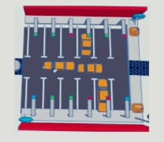

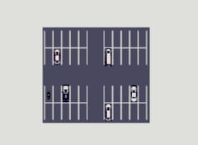

**CONCLUSION:**

the IoT-based smart parking system offers a transformative solution to alleviate urban parking challenges. By leveraging real-time data and automation, it optimizes parking space utilization, reduces traffic congestion, and enhances user convenience. This technology not only benefits drivers but also contributes to a more sustainable and efficient urban environment. As cities continue to grow, implementing such systems becomes crucial in managing limited parking resources effectively. Embracing IoT-based smart parking systems represents a significant step towards smarter, more connected cities of the future.